**WORKING ON PROJECT:-**

**Entry-:**The project starts with this section and includes two buttons name as Admin for admin login and User for User login.

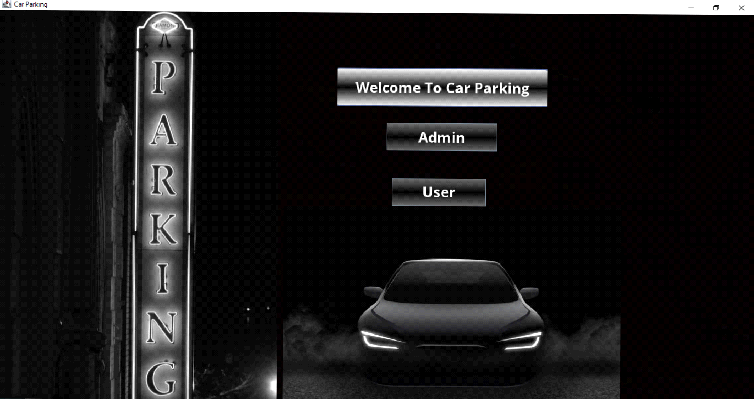

**Admin Sign In Section:-**Admin is only one as the owner of parking will be one.The Admin will login with the provided admin name and password.

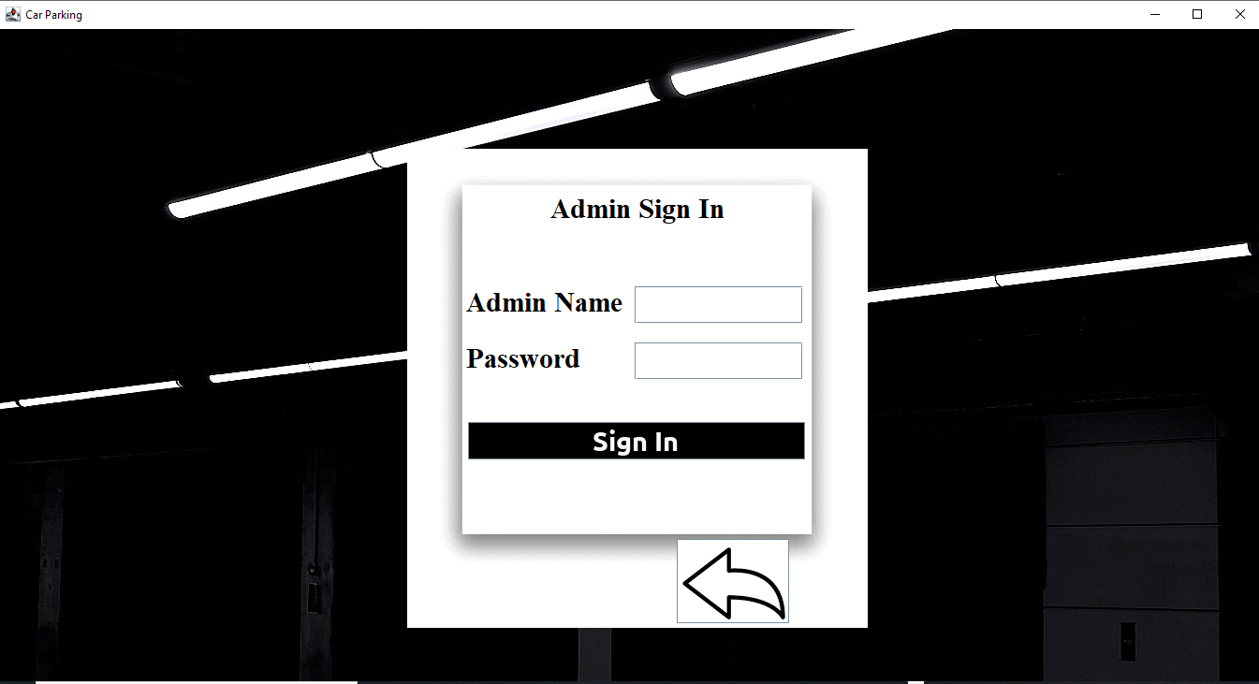

**INSIDE ADMIN BLOCK -:**After login as Admin the admin block section open’s where the admin can have the report of all the users that have parked their cars digitally .The Admin can impose fine on any user just by selecting his name on the table.The Admin can also block and unblock the user in case.And can logout later.

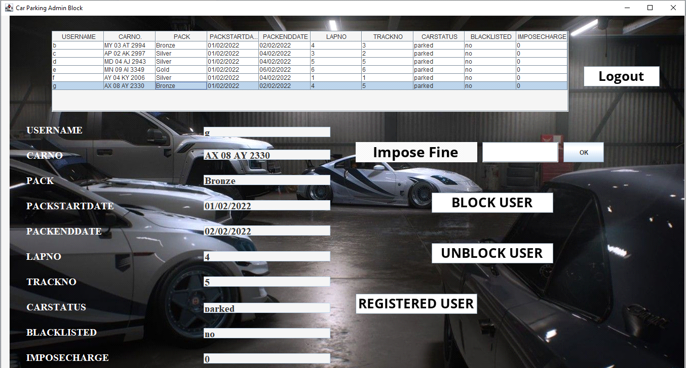

**User Blocking -:** Block User button used to block the user.When admin block any user the pop up appears as shown-:

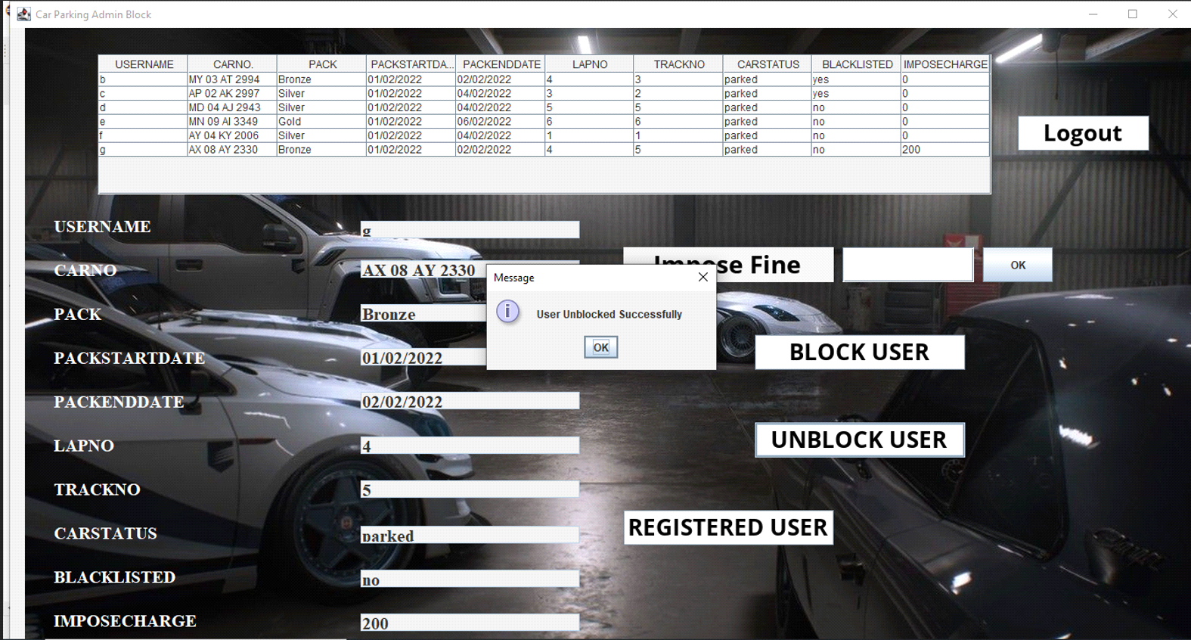

**Blocked User trying to SignUp -:** The blocked user when tries to signup into his account

The pop up appears as shown-:

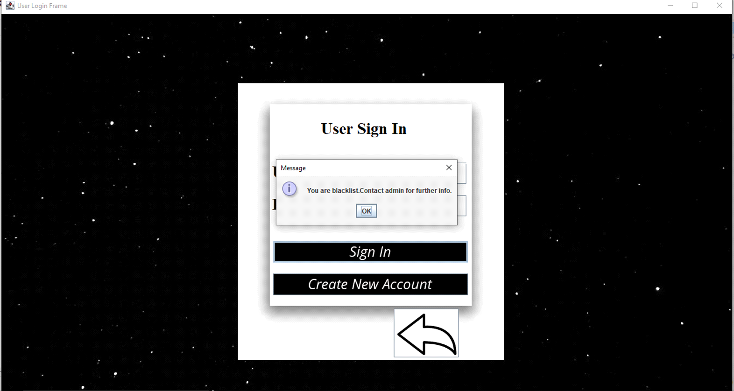

**Imposed Fine-:** We have to mention the fine that we want to impose on the user after that the pop up appears as shown-:

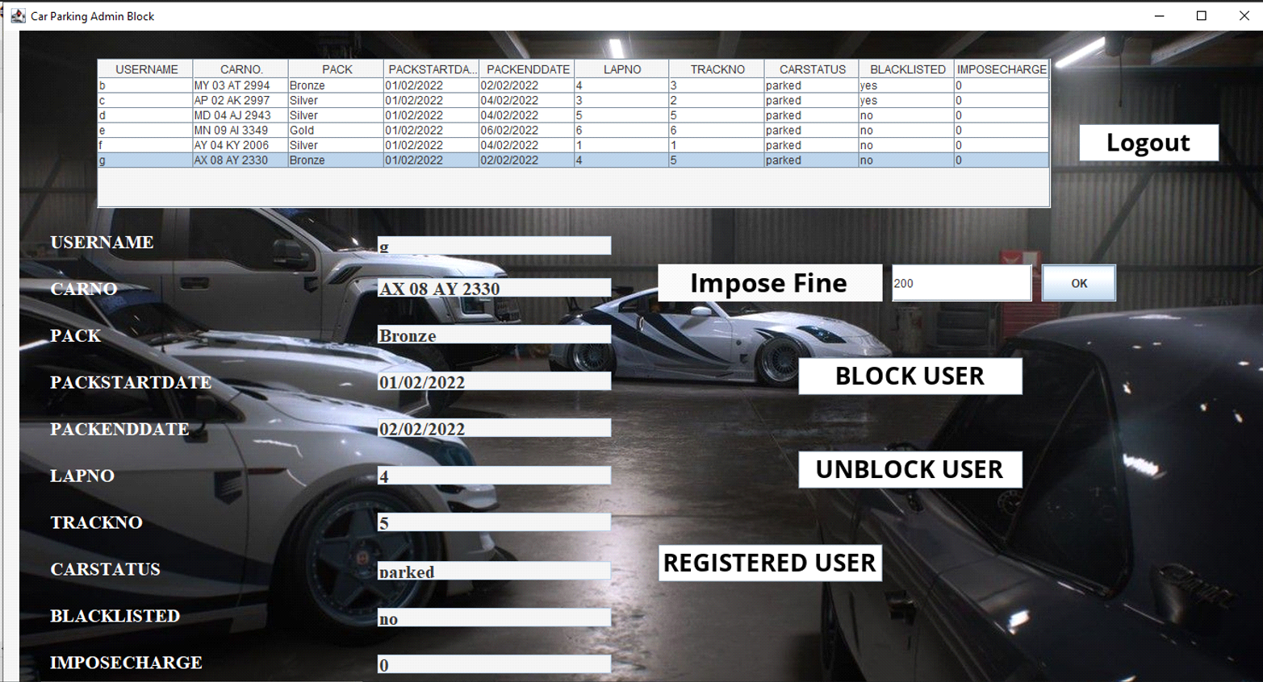

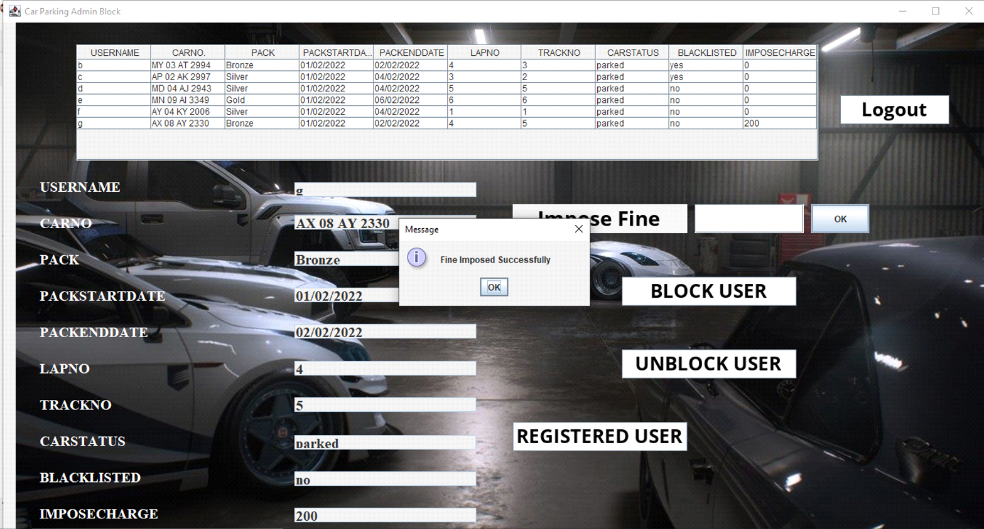

**Inside User-:** When we click on user then user sign in window appears as shown-:

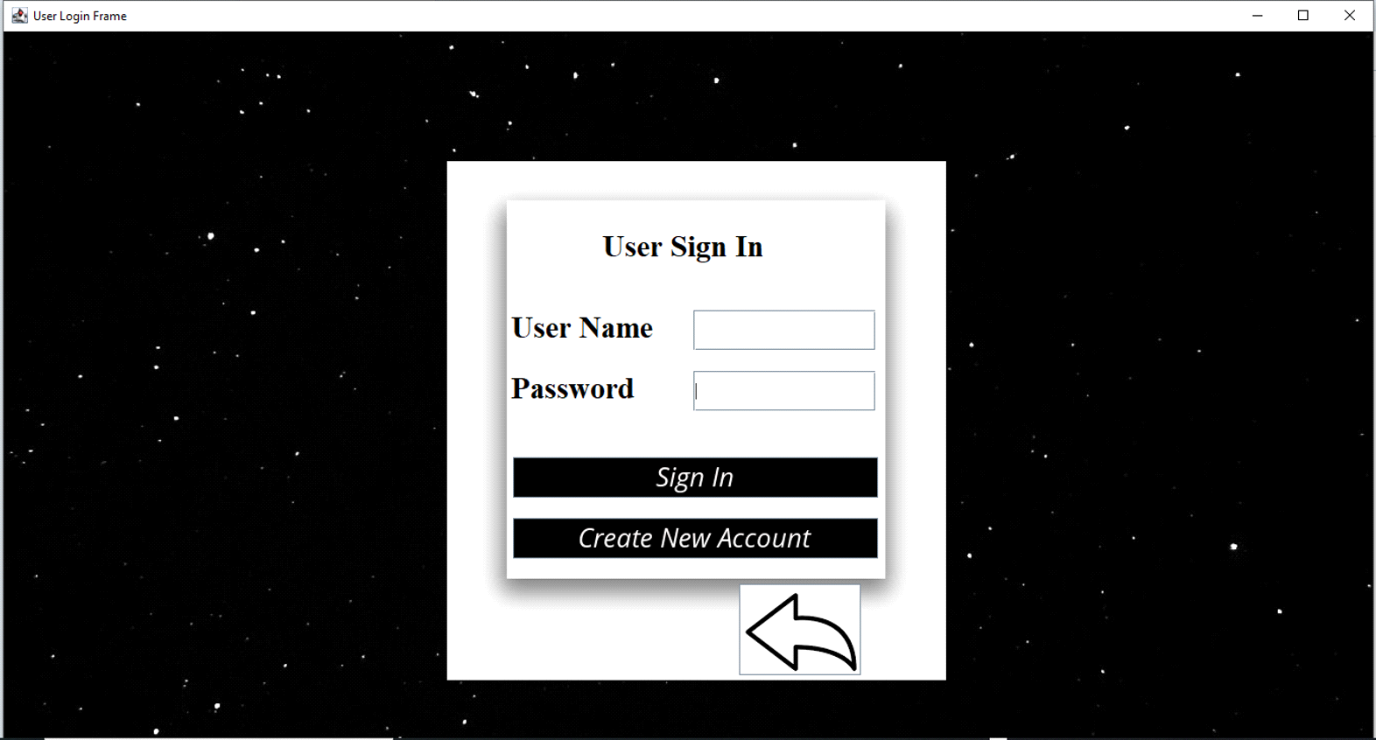

**Create New Account-:** The users can create new account by clicking over create new account button the frame appears after clicking is as shown-:

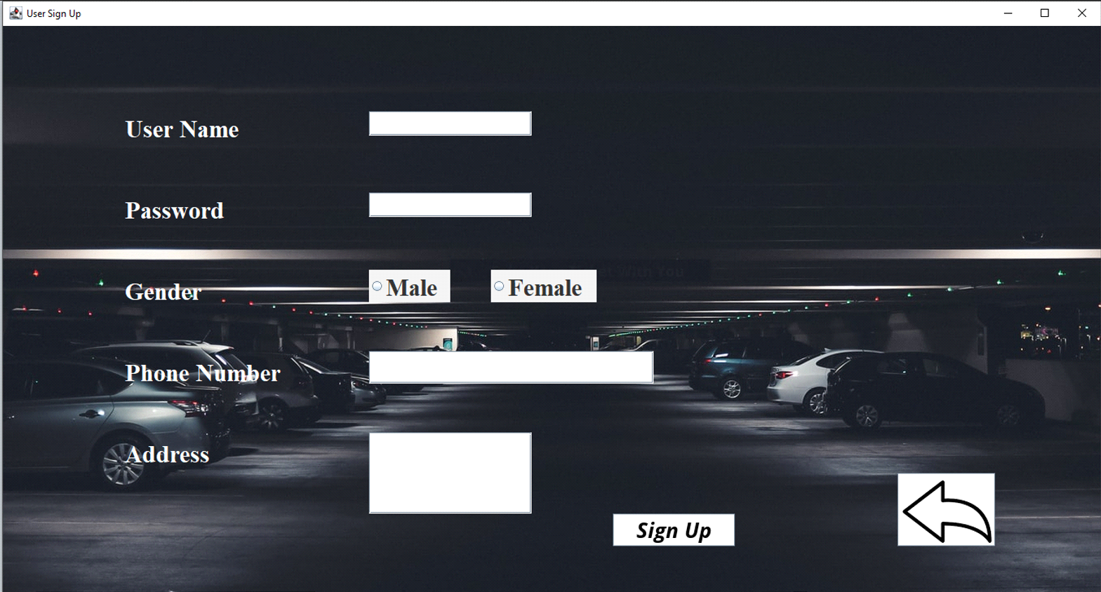

**Valid User-:** If the user is valid and new to our digital parking system then he needs to select pack and the window appears is as shown once he enters login, password-:

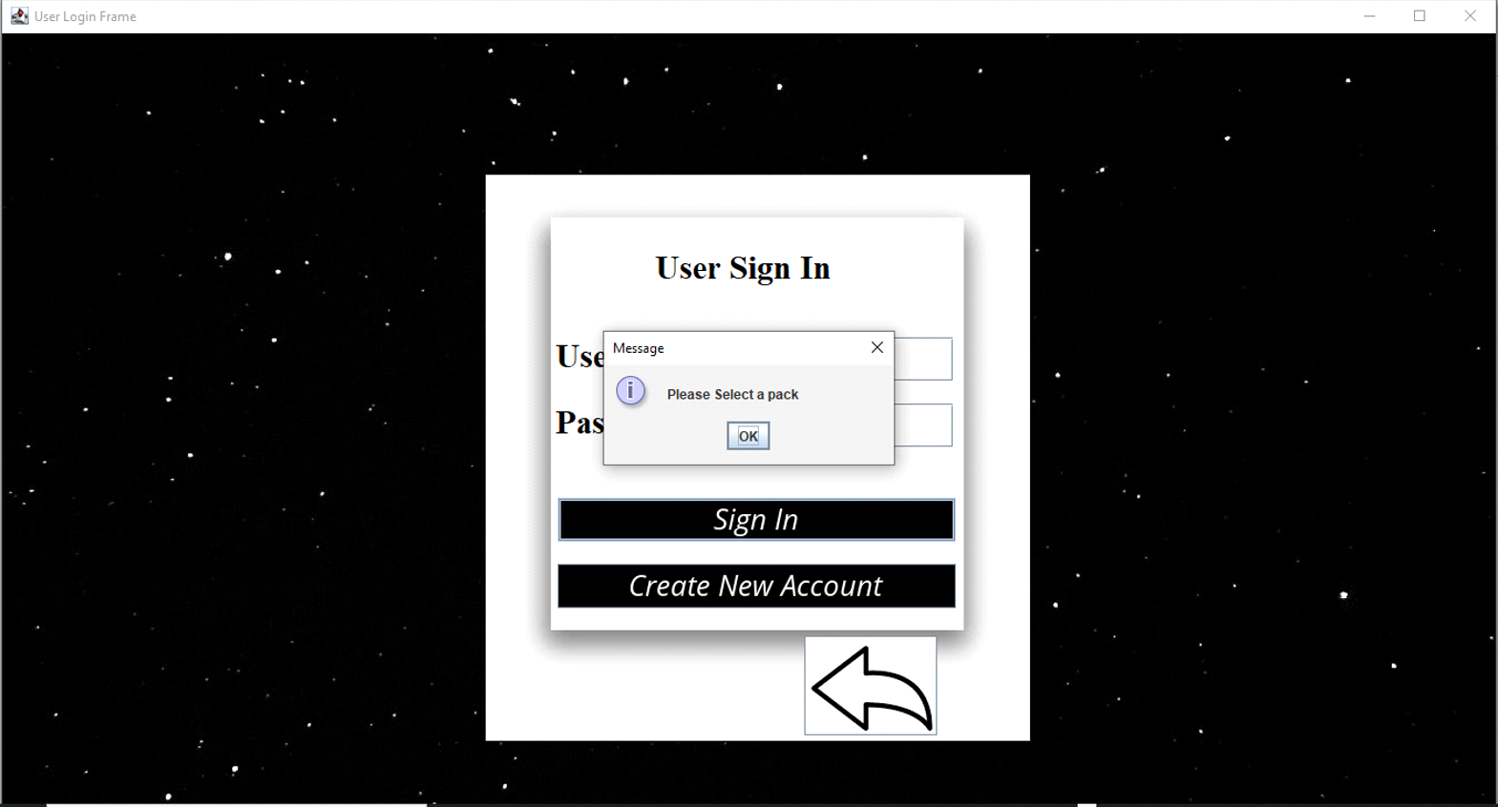

**Available Packs Window-:** Here the user needs to enter his car number, and select the pack which he wants and the window appears is as shown:-

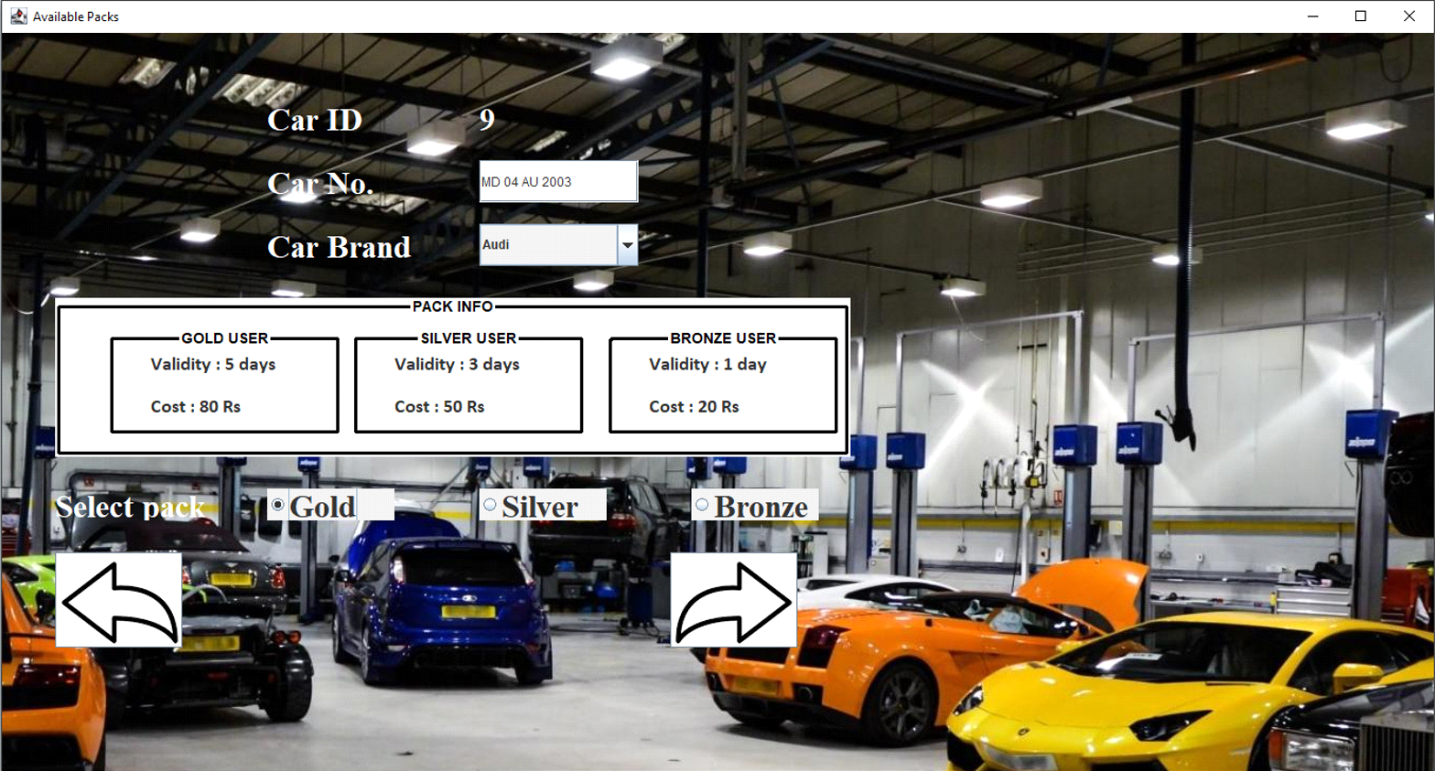

**Welcome Window-:** After the user enters his car number and select the pack then the welcome window appears as shown-:

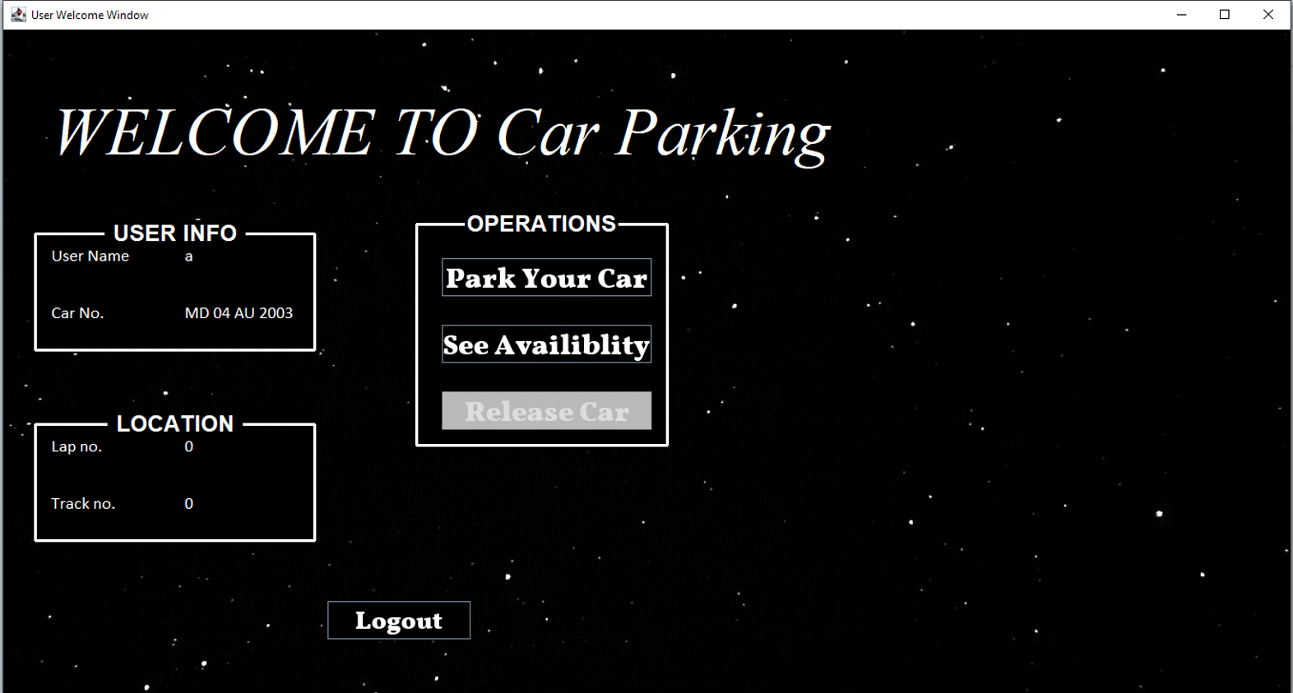

**Park Your Car –** Once the User Clicks On the Park Your car button then this window will appear-:

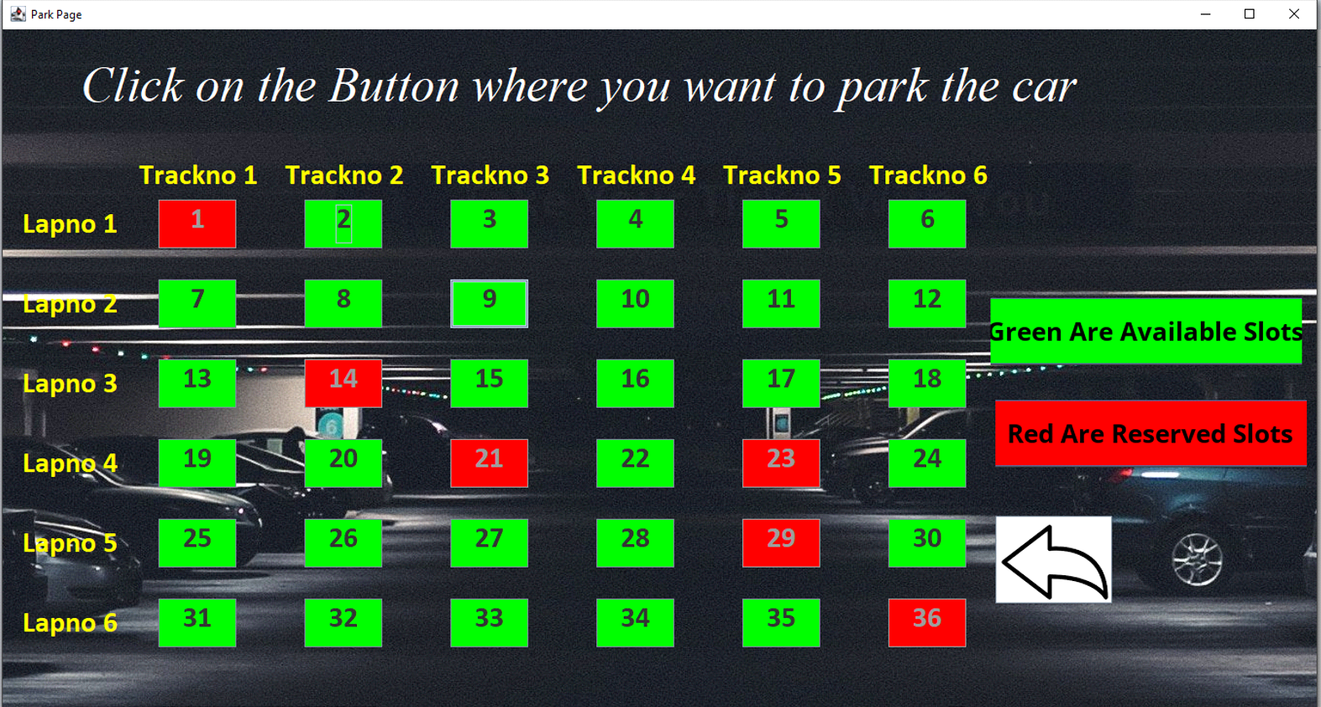

**Slot Booked Successfully-:** The user needs to select the green slots that are available one the user click on any green slots his slot gets booked and the pop up appears is as shown-:

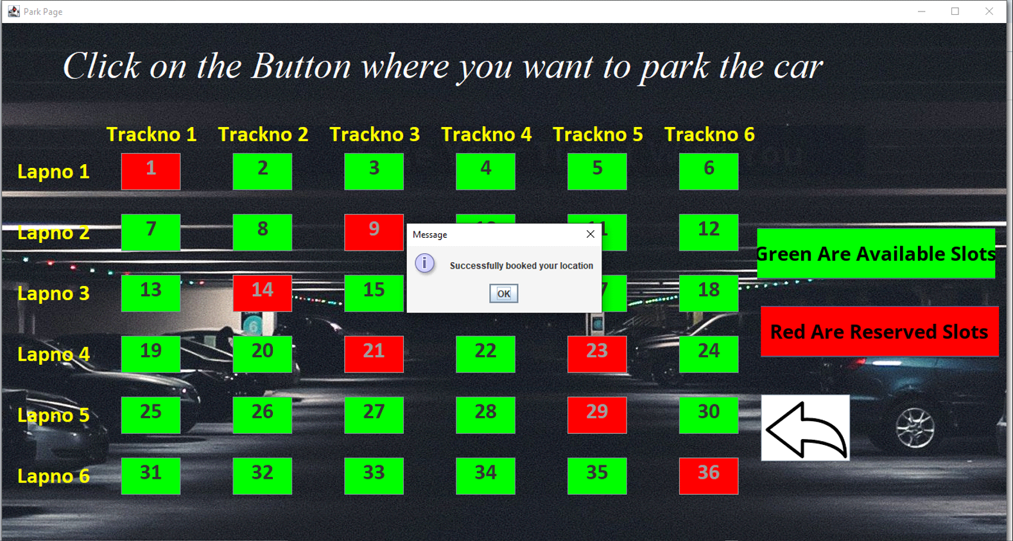

**Welcome window-:** Once the user book his slot then the welcome window appears again and this time with lap no and track no as selected by the user.

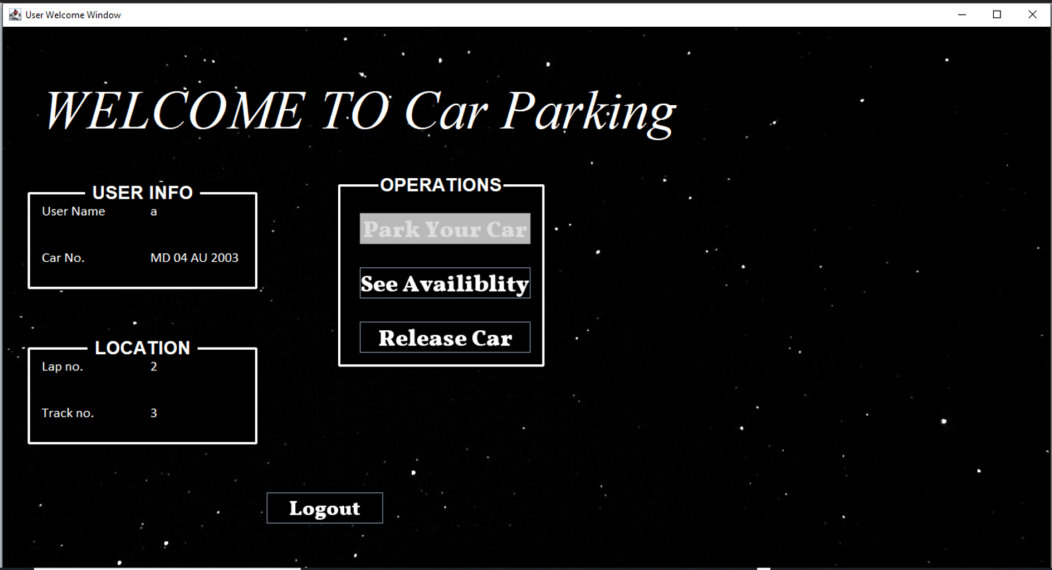

**Available Slots-:** If the user wants to see the available slot then user can click on the see availability button and the window appears is as shown-:

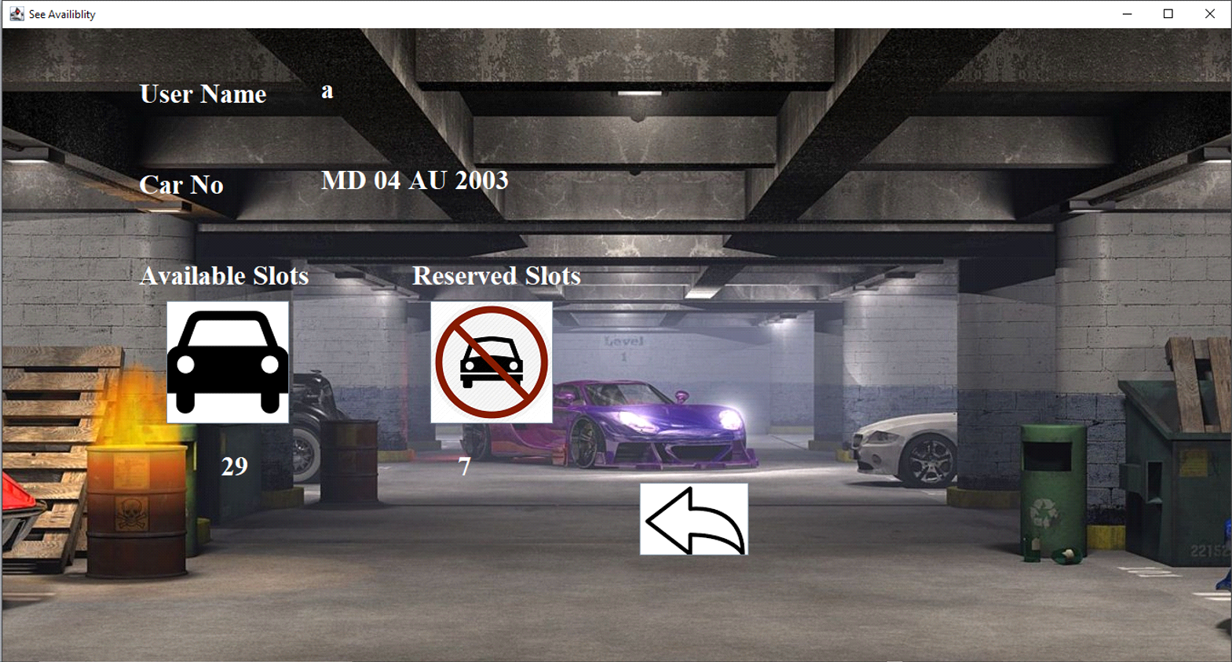

**Release Car-:** If the user wants to release car then can user can click on release car button any time and once click this pop up will appear-:

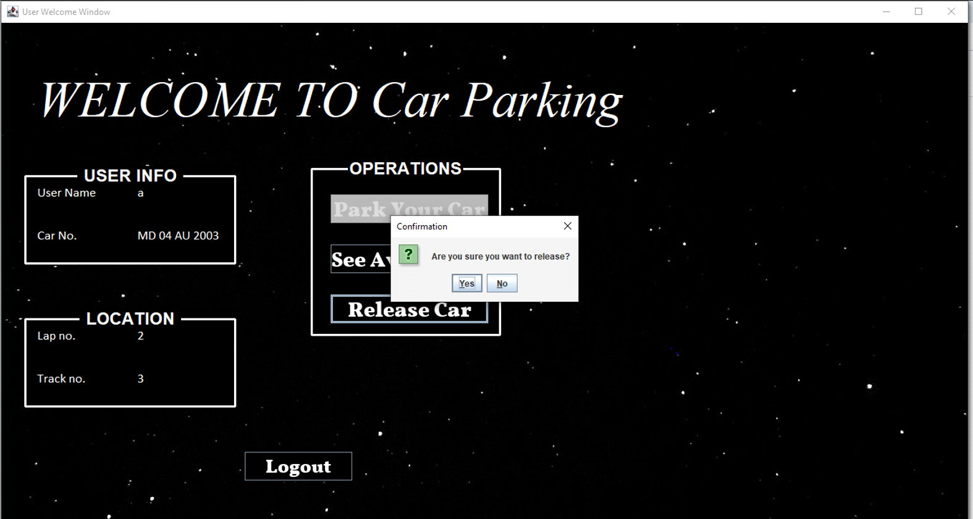

**Release Page-:** Once the user selected yes then the details of the user will be displayed and the window appears is as shown-:

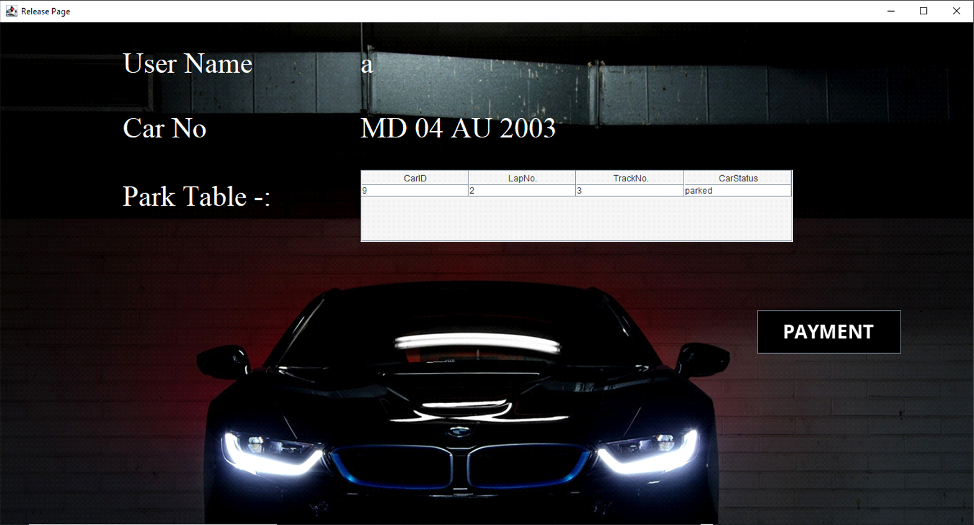

**Payment Window-:** The user needs to click on the payment button and the window appears is as shown-:

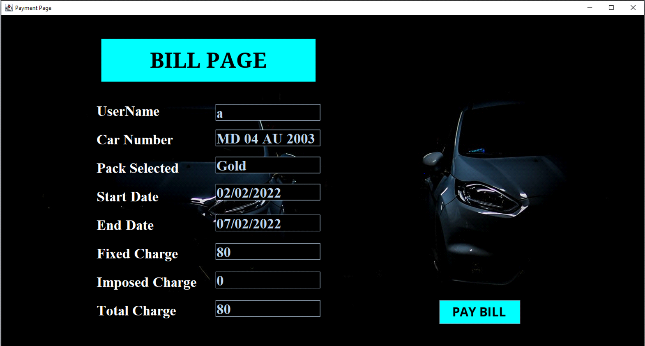

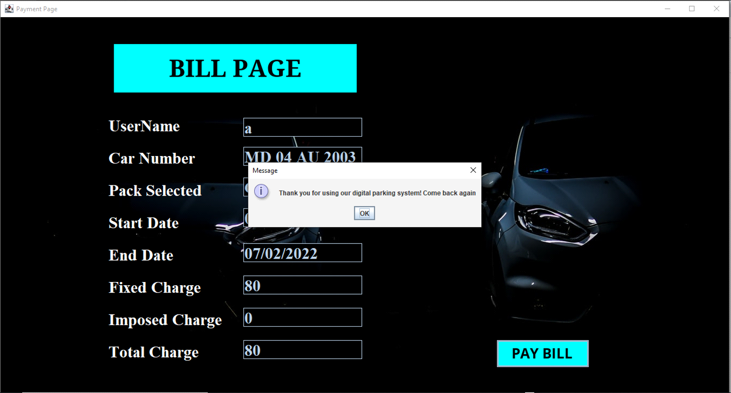

**Pack Expired -:** If the user login after the pack end date then the pop appears as shown-:

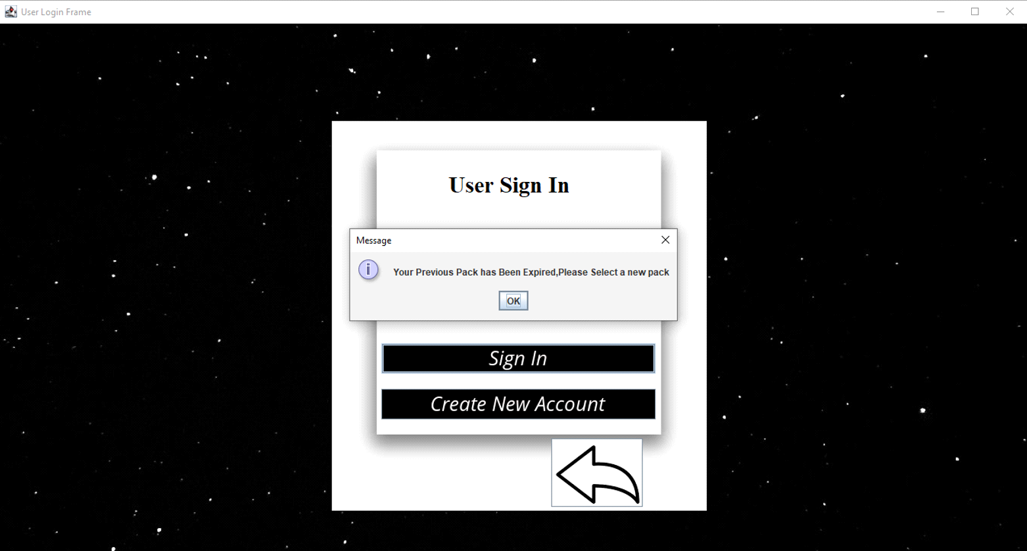

**Update Window-:** The Update window appears as shown-:

